**TITLE: - BASIC GRAPHICS FUNCTION.**

**OBJECTIVE: -**

* To understand the graphics mode and graphics function in C++
* To draw shapes like bar, 3d bar, pie, board, pie chart etc.

**THEORY: -**

BGI library provides several functions for formatting the console graphics and manipulating it. Several graphics functions used are:-

**- outtextxy(x, y, text):**

- Draws the specified `text` string at the coordinates `(x, y)`.

- It is used to display text on the screen or window.

**- bar(left, top, right, bottom):**

- Draws a filled rectangle (bar) with the specified coordinates `(left, top)` and `(right, bottom)`.

- It is commonly used to create bar charts or to fill specific areas with a solid color.

**- pieslice(x, y, start_angle, end_angle, radius):**

- Draws a pie slice centered at `(x, y)` with the specified `start_angle`, `end_angle`, and `radius`.

- It is used to create pie charts or to draw circular sectors.

**- bar3d(left, top, right, bottom, depth, topflag):**

- Draws a three-dimensional bar or column chart with the specified coordinates `(left, top)`, `(right, bottom)`, `depth`, and `topflag`.

- It creates a three-dimensional effect by adding depth to the regular bars.

**- setcolor(color):**

- Sets the drawing color for subsequent graphics operations.

- It accepts an integer value representing the color.

- It allows you to change the color used for drawing lines, shapes, and text.

**- setfillstyle(pattern, color):**

- Sets the fill pattern and color for subsequent filled shapes.

- It determines the style and color used to fill shapes created by functions like `bar()` and `pieslice()`.

- `pattern` specifies the fill pattern style, and `color` specifies the fill color.

**# WAP to draw point, line, circle, ellipse, triangle, rectangle, square, arc using C and C++.**

#include<iostream.h>

#include<graphics.h>

#include<conio.h>

#include<process.h>

#include<math.h>

#include<stdlib.h>

#include<string.h>

void main();

void call(){

getch();

cleardevice();

main();}

void main(){

int gm=DETECT, gd=0;

initgraph(&gm,&gd,"..\\BGI");

int xmax=getmaxx();

int ymax=getmaxy();

int xc=getmaxx()/2;

int yc=getmaxy()/2;

rectangle(xc-100,yc-75,xc+100,yc+60);

setcolor(10);

outtextxy(xc-30,yc-65,"LIST");

setcolor(BLUE);

outtextxy(xc-90,yc-49,"[1]. ARC");

outtextxy(xc-90,yc-35,"[2]. PIE");

outtextxy(xc-90,yc-21,"[3]. RECTANGLE");

outtextxy(xc-90,yc-7,"[4]. BAR");

outtextxy(xc-90,yc+7,"[5]. 3D BAR");

outtextxy(xc-90,yc+21,"[6]. PIE CHART");

outtextxy(xc-90,yc+35,"[7]. BAGCHAL BOARD");

outtextxy(xc-90,yc+49,"[8]. EXIT");

setcolor(3);

outtextxy(xc-60,yc+70,"CHOICE:");

char a=getch();

int x1,y1,x2,y2,r,s;

switch(a){

case '1':{cleardevice();

outtextxy(100,150,"Enter start and end angle and radius of arc");

for(int i=0;i<=10;i++){

cout<<"\n";}

setcolor(WHITE);

cin>>x2>>y2>>r;

arc(xc,yc,x2,y2,r);

call();

}

case '2':{cleardevice();

outtextxy(100,150,"Enter start and end angle and radius: ");

for(int i=0;i<=10;i++){

cout<<"\n";}

setcolor(WHITE);

cin>>x2>>y2>>r;

pieslice(xc,yc,x2,y2,r);

call();

}

case '3':{cleardevice();

outtextxy(100,150,"Enter length and breadth of rectangle:");

for(int i=0;i<=10;i++){

cout<<"\n";}

setcolor(WHITE);

cin>>x1>>y1;

rectangle(xc-x1/2,yc-y1/2,xc+x1/2,yc+y1/2);

call();

}

case '4':{cleardevice();

outtextxy(100,150,"Enter length and breadth:");

for(int i=0;i<=10;i++){

cout<<"\n";}

setcolor(WHITE);

cin>>x1>>y1;

bar(xc-x1/2,yc-y1/2,xc+x1/2,yc+y1/2);

getch();

cleardevice();

main();

}

case '5':{cleardevice();

outtextxy(100,150,"Enter length, breadth and thickness: ");

for(int i=0;i<=10;i++){

cout<<"\n";}

setcolor(WHITE);

setfillstyle(1,3);

cin>>x1>>y1>>x2;

bar3d(xc-x1/2,yc-y1/2,xc+x1/2,yc+y1/2,x2,1);

getch();

cleardevice();

main();

}

case '6':{cleardevice();

setcolor(1);

for(int i=0;i<=10;i++){

cout<<"\n";}

cout<<"Food= "; cin>> x1;

cout<<"Internet= "; cin>>x2;

cout<<"Clothing= "; cin>>y1;

cout<<"Others= "; cin>>y2;

cout<<"Radius of Pie Chart: "; cin>>r;

char f[20]="Food=", I[20]="Internet=", c[20]="Clothing=",o[20]="Others=";

char food[3], internet[3], cloth[3], other[3];

itoa(x1,food,10); //converts int value to char *const

strcat(f,food); strcat(f,"%"); // combines two char *const

itoa(x2,internet,10);

strcat(I,internet); strcat(I,"%");

itoa(y1,cloth,10);

strcat(c,cloth); strcat(c,"%");

itoa(y2,other,10);

strcat(o,other); strcat(o,"%");

rectangle(xmax-355,ymax-165,xmax-230,ymax-105);

setcolor(1);

outtextxy(xmax-350,ymax-160,f);

setcolor(2);

outtextxy(xmax-350,ymax-145,I);

setcolor(3);

outtextxy(xmax-350,ymax-130,c);

setcolor(4);

outtextxy(xmax-350,ymax-115,o);

for(i=0;i<=10;i++){

cout<<"\n";}

float fp=3.6*x1, ip=x2*3.6, cp=y1*3.6, op=y2*3.6;

setcolor(WHITE);

setfillstyle(1,1);

pieslice(xc,yc,0,fp,r);

setfillstyle(1,2);

pieslice(xc,yc,fp,fp+ip,r);

setfillstyle(1,3);

pieslice(xc,yc,fp+ip,fp+ip+cp,r);

setfillstyle(1,4);

pieslice(xc,yc,fp+ip+cp,fp+ip+cp+op,r);

getch();

cleardevice();

main();

}

case '7':{cleardevice();

outtextxy(xc-200,0,"Enter the size of board: ");

setcolor(WHITE);

setfillstyle(1,3);

cout<<endl<<"\t\t";

cin>>r;

int size=r/(sqrt(2));

int half=size/2;

rectangle(xc-size,yc-size,xc+size,yc+size);

line(xc-size,yc,xc+size,yc);

line(xc,yc-size,xc,yc+size);

line(xc-size,yc,xc,yc-size);

line(xc-size,yc,xc,yc+size);

line(xc,yc+size,xc+size,yc);

line(xc+size,yc,xc,yc-size);

rectangle(xc-half,yc-size,xc+half,yc+size);

rectangle(xc-size,yc-half,xc+size,yc+half);

line(xc-size,yc-size,xc+size,yc+size);

line(xc-size,yc+size,xc+size,yc-size);

getch();

cleardevice();

main();}

case '8': exit(0);

default:{cleardevice();

setcolor(RED);

outtextxy(xc-100,yc,"CHOOSE VALID OPTION");

getch();

cleardevice();

main();}}}

**OUTPUT**: -

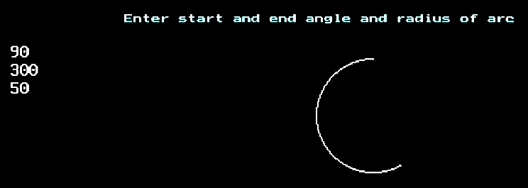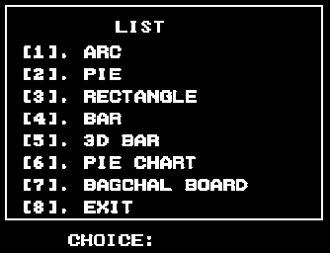

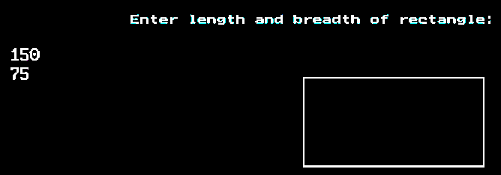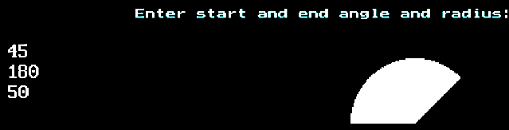

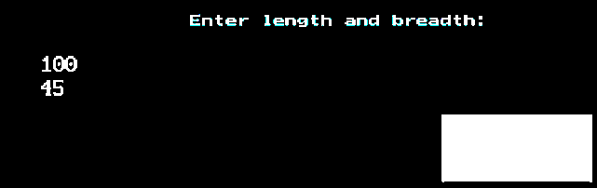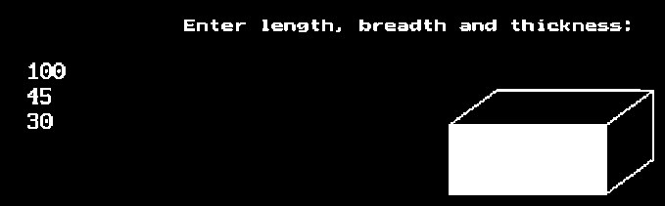

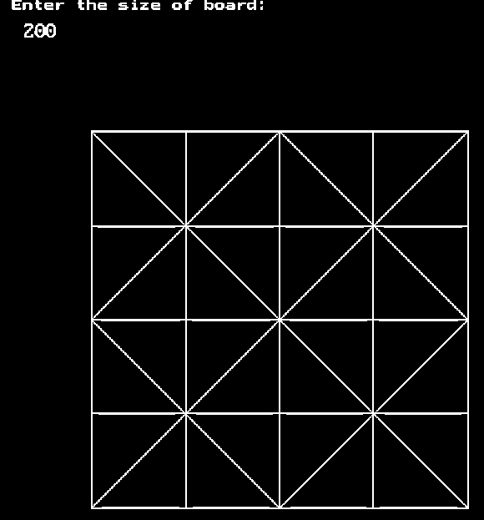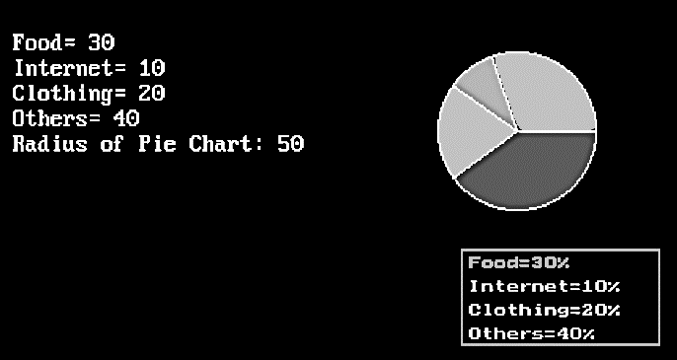

**CONCLUSION**: -

In conclusion, In summary, the graphics.h library is a graphics library used in older versions of C and C++. It provides functions for drawing basic shapes such as lines, rectangles, circles, and ellipses. Additionally, it allows for displaying text on the screen. However, it's important to note that graphics.h is specific to certain compilers and operating systems, and newer graphics libraries are typically used for modern graphics programming.